**PRIORITY CPU SCHEDULING ALGORITHM:**

#include<stdio.h>

#include<unistd.h>

int main()

{

int p[20], bt[20], pri[20], wt[20], tat[20], i, k, n, temp;

float wtavg, tatavg;

printf("Enter the number of processes --- ");

scanf("%d",&n);

for(i=0;i<n;i++)

{

p[i] = i;

printf("Enter the Burst Time & Priority of Process %d --- ",i);

scanf("%d %d",&bt[i], &pri[i]);

}

for(i=0;i<n;i++)

for(k=i+1;k<n;k++)

if(pri[i] > pri[k])

{

temp=p[i];

p[i]=p[k];

p[k]=temp;

temp=bt[i];

bt[i]=bt[k];

bt[k]=temp;

temp=pri[i];

pri[i]=pri[k];

pri[k]=temp;

}

wtavg = wt[0] = 0;

tatavg = tat[0] = bt[0];

for(i=1;i<n;i++)

{

wt[i] = wt[i-1] + bt[i-1];

tat[i] = tat[i-1] + bt[i];

wtavg = wtavg + wt[i];

tatavg = tatavg + tat[i];

}

printf("\nPROCESS\t PRIORITY\tBURST TIME\tWAITING TIME\tTURNAROUND TIME\n");

for(i=0;i<n;i++)

printf("\nP%d \t%d \t\t%d \t\t%d \t\t%d \n",p[i],pri[i],bt[i],wt[i],tat[i]);

printf("\nAverage Waiting Time is --- %f\n",wtavg/n);

printf("\nAverage Turnaround Time is --- %f\n",tatavg/n);

printf("\nPress Enter to continue...");

getchar(); // equivalent to getch()

return 0;

}

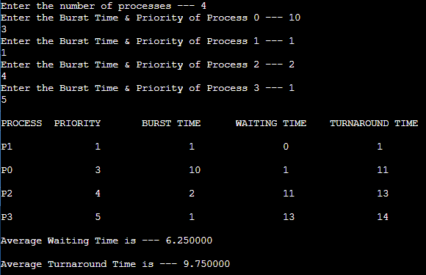**OUTPUT:**